Google API’s

# Google Maps API

Using the Google Maps API will allow our app to display a basic map with map markers. The API can also be used for planning routes, displaying weather and showing specific locations (shops, cafes etc.). In order to use the API HTML and JavaScript will have to be used in order to implement these features. Depending on the platform either Google Maps Android API or Google Maps SDK for iOS will need to be used.

Use of the Google Maps API and its costs depend upon the business model of our service. Google offers free use of the Maps API for any app of web service that is free for anyone to use. If the app or web service is paid for/requires the user to pay for access to the app or web service, then in order to use the API we a free standard plan or premium plan. This also applies for apps or services that are invite only. If we were to implement a future requiring use to track/monitor other users and their vehicles (which is our key feature) then a premium plan is needed to use the API (https://developers.google.com/maps/pricing-and-plans/).

## Plans

|  |  |
| --- | --- |
| **Standard** | **Premium** |
| Free, external, and publicly available implementations | Licenses for internal, OEM, and asset tracking implementations |
| Unlimited, free usage of Google Maps Android API and Google Maps SDK for iOS | Annual contracts with enterprise terms2 |
| Pay for uplifts above usage limits | 24-hour technical support |
| Individual API pricing and usage limits | Service level agreement (SLA) |
|  | Guaranteed ad-free and enhanced API features |

## Pricing Details (Android and iOS)

|  |  |
| --- | --- |
| **Standard** | **Premium** |
| Unlimited free usage | Pricing based on volume |
| 1000 free requests per day, 150,000 free requests upon payment certification. |  |

For premium plans, a quota for the amount of times the maps load has to be purchased in the form of Maps API Credits. Credits usage can be seen in the following chart:

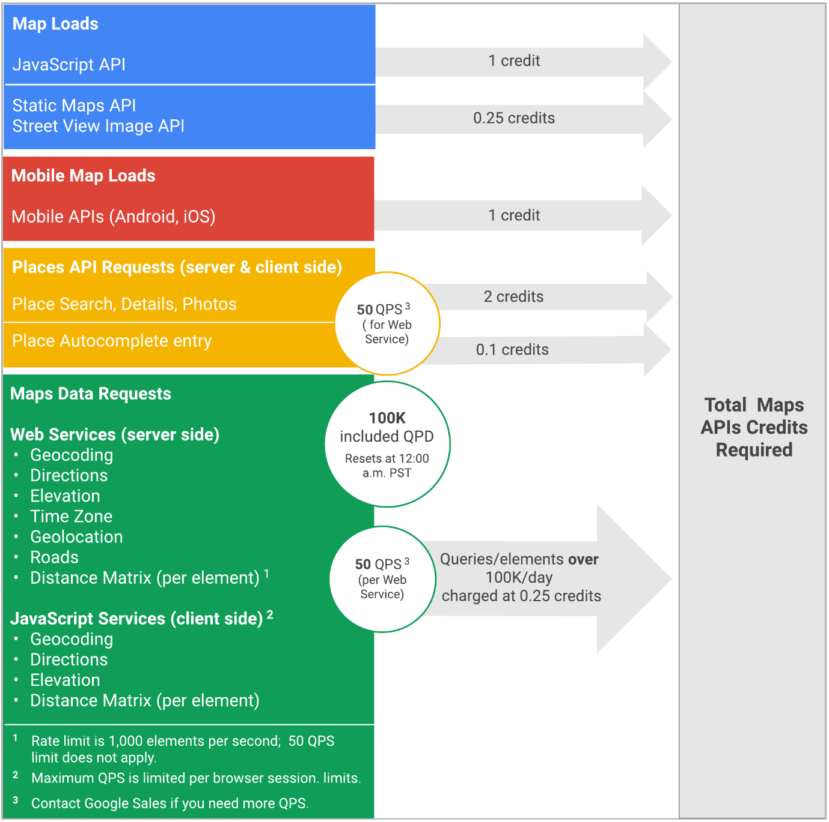

# Google Maps Geolocation API

This API is part of the Google Maps API, this allows the gathering of user’s locations with an accuracy radius using information provided by cell towers and WiFi nodes found. This API will enable our app to see other cars/users on the map and communicate based on a pre-set radius from the car. This API uses HTTPS and POST formatted in a JSON document. Use of this API is included within the Google Maps API plan.

# Google Places API

This API is standalone form the Google Maps API but is still included in the basic plan of the Google Maps API and allows the app to deliver information such as opening times and popular times about specific locations, businesses, shops, restaurants etc. The API also includes the Place Picker and Place Autocomplete features.